# CLOUD PERFORMANCE ANALYSIS WITH CLOUD ANALYST

**Exp No.:** 11

**Date:** 01-06-2022

# AIM:

To perform cloud performance analysis with Cloud Analyst tool.

# PROCEDURE:

1. Download Cloud Analyst zip file and NetBeans IDE.
2. Unzip the cloud analyst file.
3. Open NetBeans and open the cloud analyst extracted file.

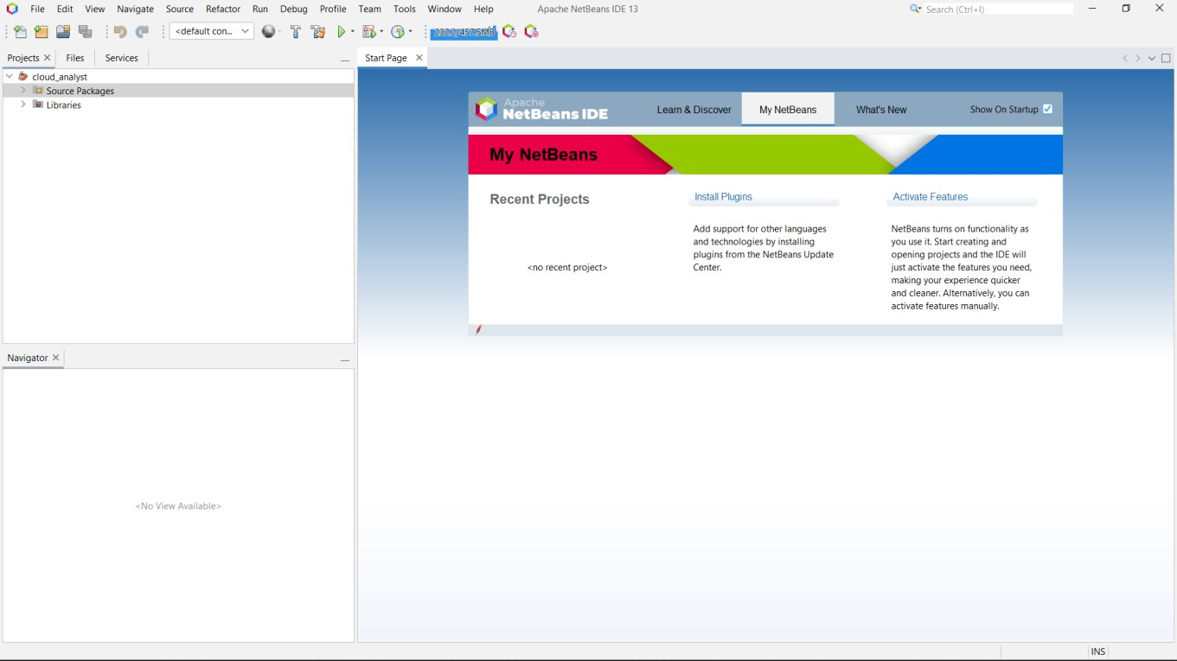

1. Run the project.
2. The cloud analyst tool will be opened in a new window.

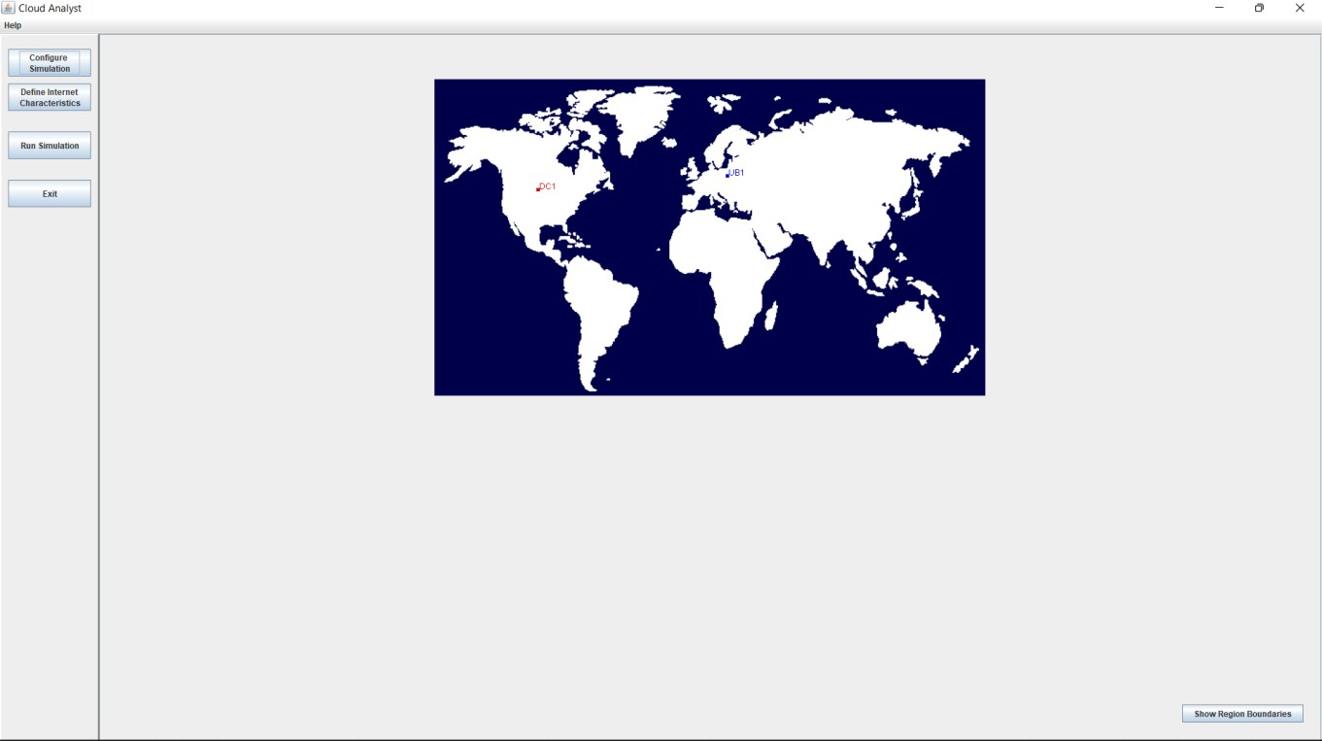

1. Here, DC represents Data Center and UB represents User Base.
2. Select the **Show regions boundaries** button in the right bottom corner to view the 6 regions from R0 to R5 segregated across the world.

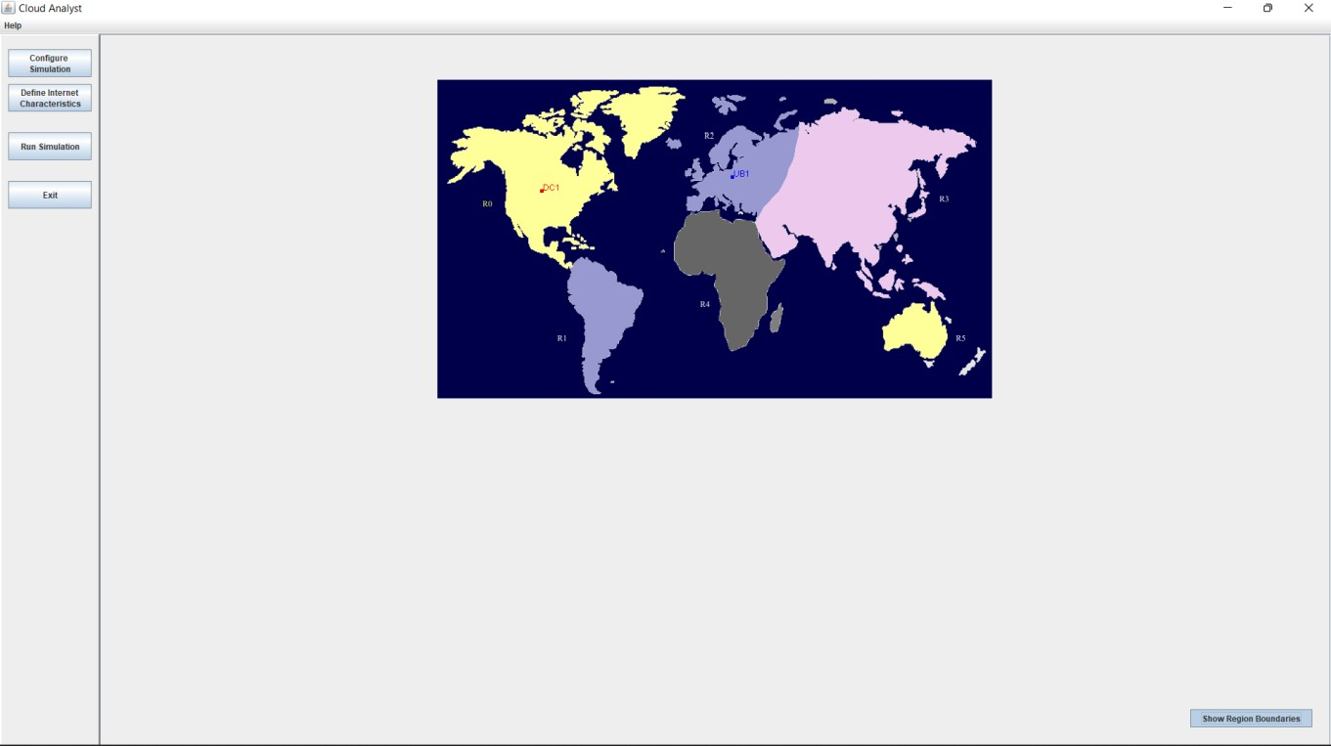

1. Select the Configure simulation button in the left panel to configure the user bases and data centers.

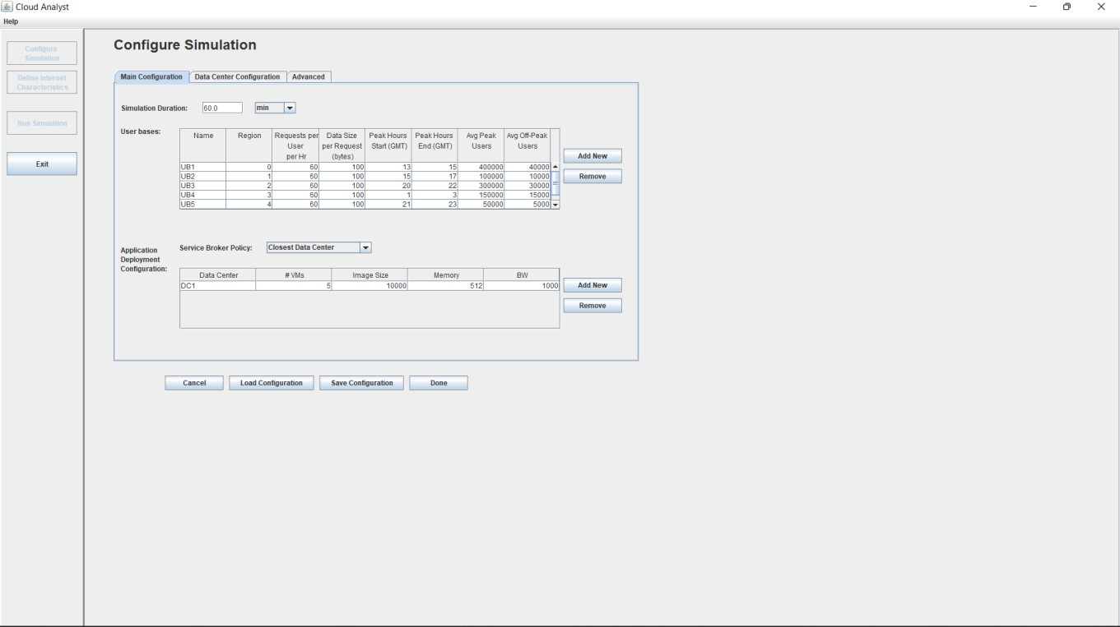

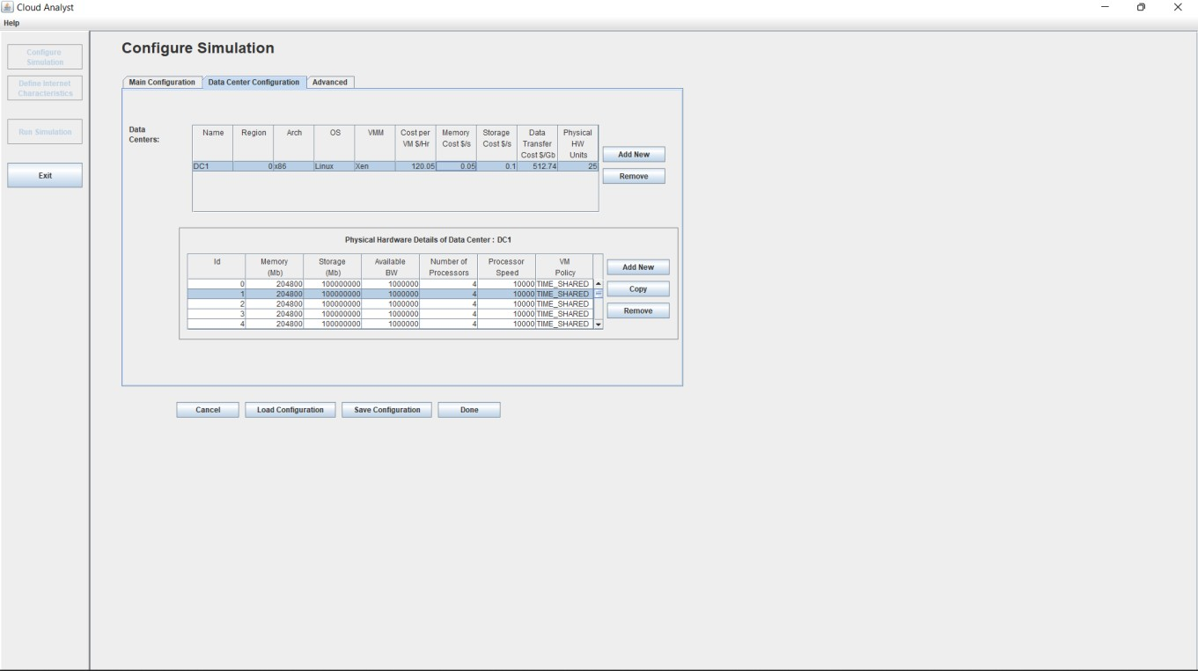

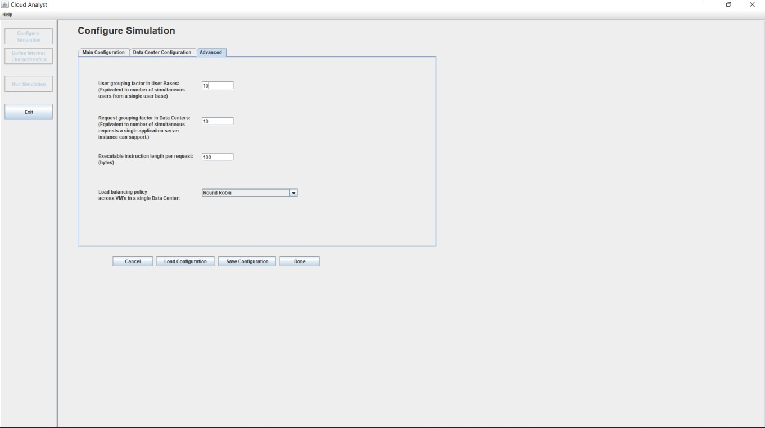

1. Set the configurations for the userbases and data centers.
2. To save the configuration, select save configuration button and click on done.
3. Select the run simulation button from the left panel to start the simulation.
4. 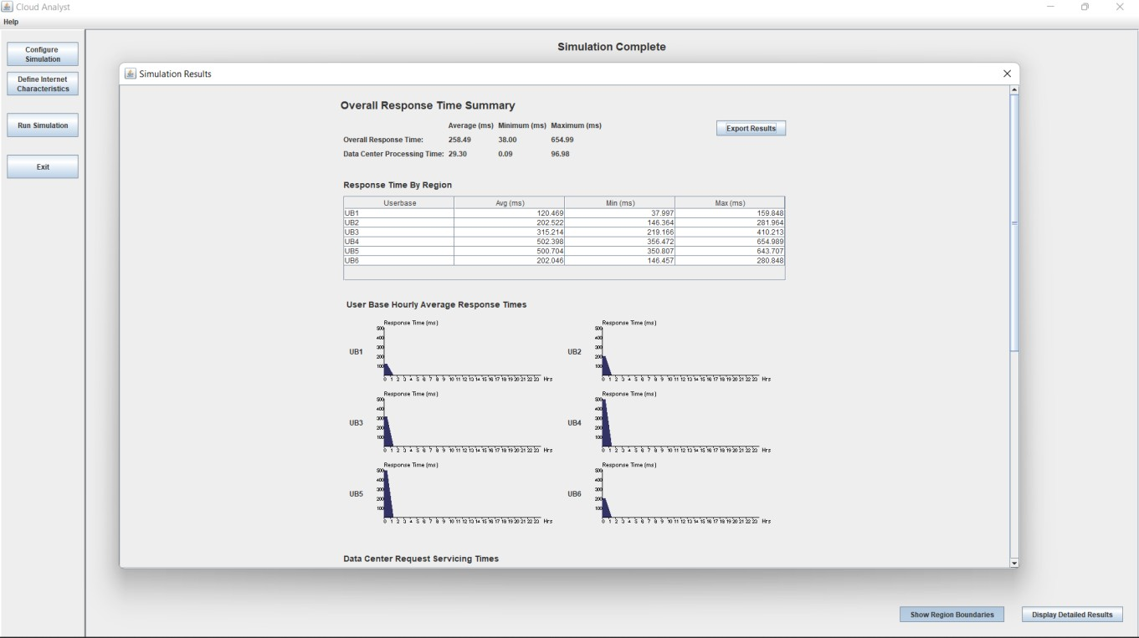After the simulation is done, we can view the results.

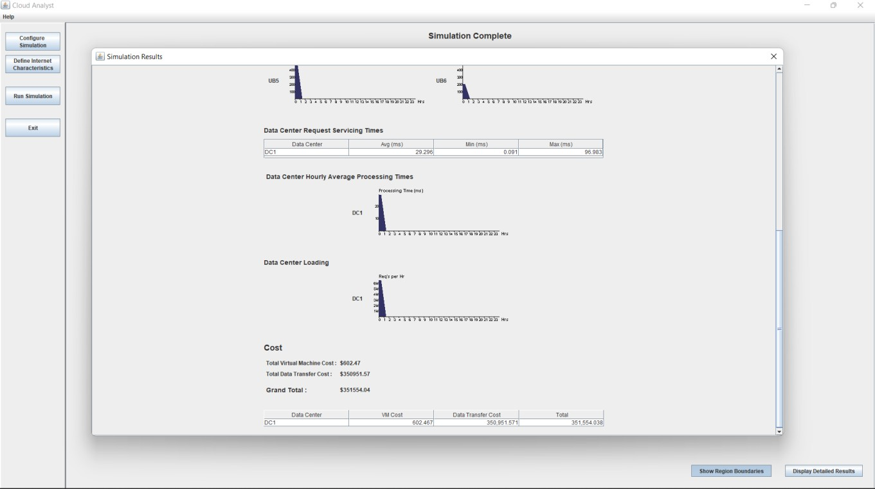

1. 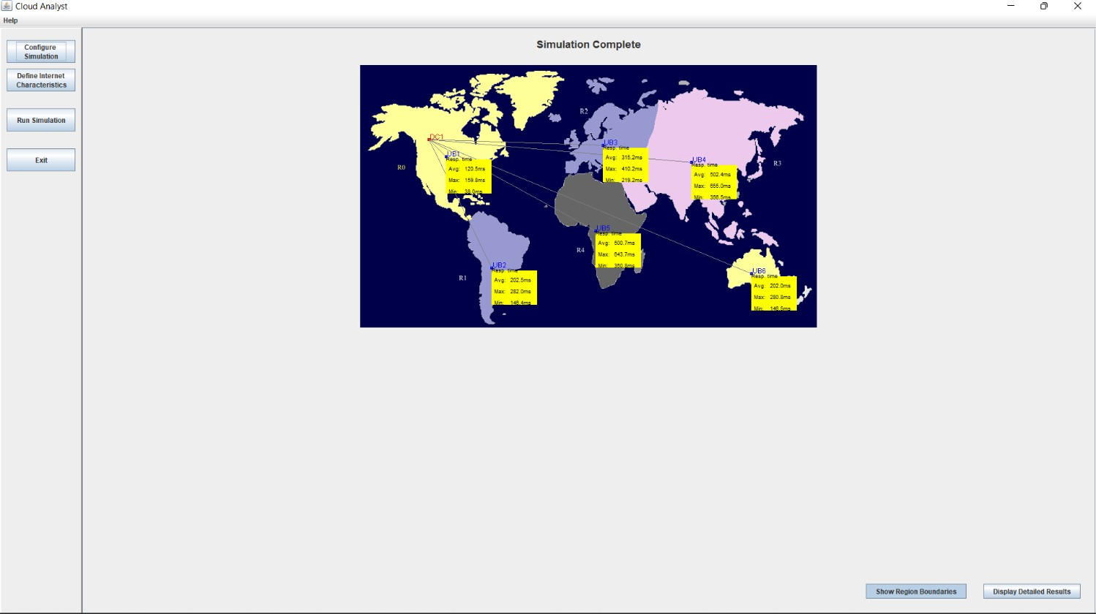The performance can be analyzed similarly for different cloud configurations.